Curriculum Vitae (C.V.)
- Personal data:
Name (Arabic) | مرام طاهر محمد الهادي
Name (English) | Maram Taher Mohamed Alhady
Department | Pathology
College | Benha University
Academic degree | Assistant Lecturer
Office Address
Mobile 1 | 01010680789
Home phone
Work phone
Fax
Email (university) | Maram.abdlehalem@fmed.bu.edu.eg
Email (alternative)
Web site (if any)
Recent Photo (passport format) | 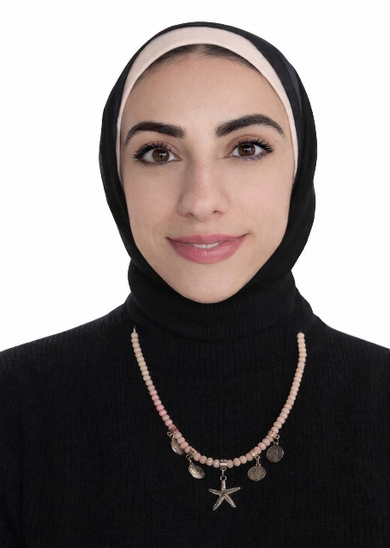
- Education:
2.A. Degree obtained;
Institution | Degree obtained | Year
Faculty of medicine | MB,BCh | 2017
Faculty of medicine | Msc of Pathology | 2024

2.B. Specialty;
General specialty. | Pathology
Specific specialty.

2.C. Language skills (Excellent, Very Good, Good or Basic);
Language | Reading | Speaking | Writing
Arabic. | Excellent | Excellent | Excellent
English. | Excellent | Very good | Excellent
French. | Basic | Basic | Basic
Other (specify).

- Positions:
Tittle | Year | University/Institution
Demonstrator | 2019-2024 | Benha faculty of Medicine
Assistant lecturer | 2024-present | Benha faculty of Medicine

- Cooperation with local and international entities having website:
( جامعة – مؤسسة - وزارة – مركز بحثي – عضو هيئة تدريس – باحث - شركة – مصنع – الخ)
Name of local and international entity | Website
- Membership of professional bodies (List):

- Membership of institute (List):

- Distinction and Awards (List):

- Academic:
Courses at under graduate level;
1. Course name: | Clinical rounds;
2. Course name: | Lectures;
Courses at post graduate level;
1. Course name: أخلاقيات البحث العلمى  TOEFl  SCU- التحول الرقمي  الكتابة العلميه  الاحصاء | Clinical rounds;
2. Course name: | Lectures;
- Areas of research:

- PhD/M.Sc Supervision:
Title | PhD/M.Sc | Year completed / in progress

- Grants for Projects:
Funding organization | Project title | Role | Year
- Committees:

- List of Publications:
M Abdalla, Rana, Maram T Alhady, Heba M Rashad, Nashwa M Emarah, and Naglaa H Shalan. "Significance of Sex Determining Region Y-Box transcription factor 4 (SOX4) expression and Nuclear morphometry in endometrial carcinoma." https://journals.ekb.eg/article_349818.html.
14. Attended Workshops, Symposiums, and Conferences: "List name and year";

Name of Workshops, Symposiums, and Conferences | Year
13.1.

- Books published:

16. Positions:
 | Date | Organization | Country | Position
1
2
3

17. Activities in faculty/university/community service:
Name of Activity service | Year
- Teaching (Rounds and lectures). | 2019-till now
- Clinical meeting.
- Making conferences.
- Medical Convoys.
- Workshops.
18. Consulting Experience (if any):

19. Additional information you would like to put on the website:

